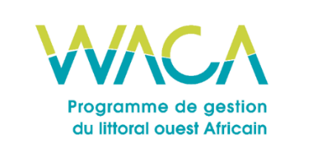
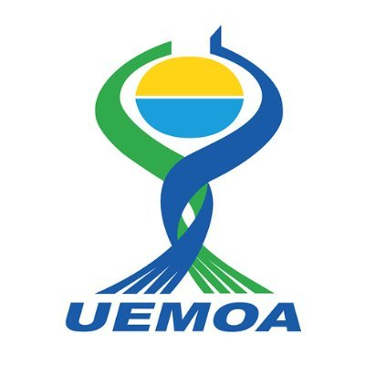
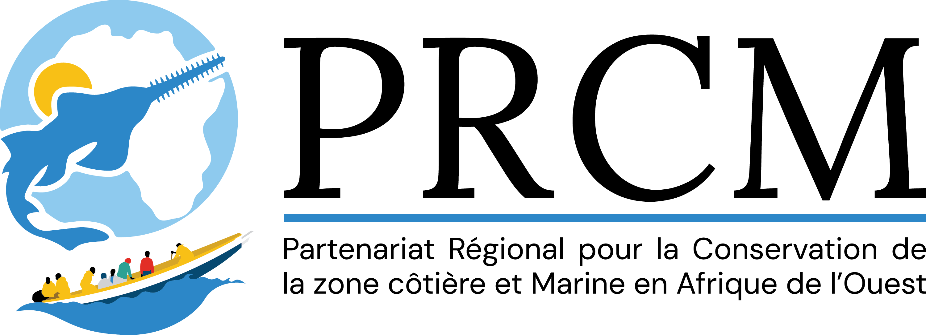

📘 FULL APP FORM (PRCM / WACA ResIP)

This form serves as the official framework for candidates wishing to submit a complete project within the framework of the PRCM/WACA/ResIP Call for Projects. The italicized instructions (including this one) provide guidelines to guide you through writing each section. They must be deleted in the final version sent to the PRCM.

🟦 I. GENERAL INFORMATION ON THE PROJECT
The purpose of this section is to present basic information about the project and the lead organization. It enables verification that the project is well-aligned with the priorities of the WACA ResIP program and that the lead organization is clearly identified. Each field must be filled in precisely.
📘 Detailed instructions:
• The title of the project should be clear, precise, and reflect the main objective of your intervention.
• The chosen theme must correspond to the three priorities of the call. Check ONLY ONE box.
•The CSO must be specified (NGO, association, EIG, etc.) and attach the corresponding legal document.
• Indicate the intervention area(s) with precise geographical markers (if possible).
• The total amount must include the PRCM contribution and all other expected contributions.
• If you are in a consortium, specify the roles of each member and attach a letter of commitment signed by the members.

Full title of the project (To be completed by the applicant)
📌 Please fill in the table below with the requested information:
Main theme of the call for projects (tick only one):  ☐ Ecosystem Restoration & Conservation  ☐ Local Governance & Citizen☐ Mobilization Innovations for Socio-Economic Resilience | To be completed by the candidate
Candidate's full name | To be completed by the candidate
Legal status of the candidate (attach proof in appendix) | To be completed by the candidate
Country of intervention | To be completed by the candidate
Precise geographical area (describe the locality, municipality, region concerned) | To be completed by the candidate
Estimated duration of the project (in months) | To be completed by the candidate
Total amount of the project (in euros) | To be completed by the candidate
Amount requested from the PRCM (in euros) | To be completed by the candidate
Amount and sources of co-financing (in-kind and/or cash, indicate whether confirmed or not) | To be completed by the candidate
Other members of the consortium (if there is a consortium) | To be completed by the candidate

🟦 II. IDENTITY OF THE HOLDER AND STRUCTURE OF THE CONSORTIUM (if applicable)
This section aims to demonstrate that the applicant entity or consortium has the legal, technical, and organizational capacity to carry out the proposed project.
📘 Detailed instructions:
• Briefly describe your structure, its mandate, its areas of intervention, and its presence in the project area.
• Attach your legal status, registration number, and any official documents.
• If you are submitting on behalf of a consortium, specify the roles of each member, attach a signed letter of commitment, and complete the following fields for the consortium in the following table.

Name of the supporting organization | To be completed by the candidate
Brief presentation of the organisation (missions, areas of action, territorial anchoring, national/regional recognition) | To be completed by the candidate
Year of creation | To be completed by the candidate
Full contact details (address, phone, email, website) | To be completed by the candidate
Name, position and contacts of the person responsible for the project | To be completed by the candidate
In the case of a Consortium:  • Name of the Lead Partner  Partner members (Name, mission, role in the project, area of intervention):  • Attach the legal documents of the members and the letter of commitment of the group. | To be filled in

🟦 III. BACKGROUND AND RATIONALE
Objective: This section provides an understanding of the current situation in the targeted area, including the ecological and socio-economic issues, as well as the existing dynamics that justify the project.
📘 Detailed instructions:
• Describe, if relevant, the ecological context of the area (state of ecosystems, habitat types, existing pressures).
• Describe, if relevant, socio-economic aspects (lifestyles, livelihoods, populations concerned).
• Mention current or past projects in the area or related to the issue, partnerships, synergies, and opportunities.
• Use real-world, localized data. Add a map as an appendix if necessary.
Write your text and justification here (maximum two pages):
…

🟦 IV. PROBLEMS AND CHALLENGES
Objective: To identify the problem(s) to be solved and the priorities for action.
📘 Detailed instructions:
• Describe the primary issue that your project aims to address (in relation to the selected theme).
• Explain the likely consequences of inaction (degradation, increased vulnerability, exclusion, etc.).
• Integrate an initial analysis of possible risks (social, environmental, operational, etc.).
• Illustrate with concrete examples or situations.
Write your text here (1 page maximum):

🟦 V. INTERVENTION STRATEGY AND PROJECT DESCRIPTION
Objective: Demonstrate a clear understanding of the project's goals, anticipated outcomes, and the strategies for achieving those outcomes. This section is the most important part of the form.
📘 Detailed instructions:
This section should allow the selection committee to understand how the project intends to provide concrete, measurable, and realistic solutions to the problems identified. It must describe the objectives sought, the expected results, the main activities to be carried out, and the method of intervention in a structured manner. It is recommended that this section be presented on a maximum of 3 to 4 pages.
• Define an overall goal in one clear and affirmative sentence (e.g., Improve the resilience of X communities through Y).
• Outline up to three specific objectives (each related to a type of expected action or change: e.g., ecological restoration, capacity building, community advocacy, etc.).
• Clearly outline the concrete results anticipated at the end of the project regarding each specific objective. The results should be measurable and achievable (e.g., number of people trained, surface area restored, tools created or developed, etc.).
• Describe or list the main activities intended to achieve each specific objective (be concise and precise: this is not a detailed operational plan, but rather an overview of the major actions).
• Describe your methodological approach: how will the project be implemented in practice? What are the key steps, methods, tools, or guiding principles?
• Present a logical framework in table format (to be attached as an appendix) to clarify the project's logic and demonstrate how each activity leads to an outcome that contributes to an effect supporting a desired impact.

✏️ To be completed below (Maximum 3 to 4 pages):
• Overall objective: ...
•Specific objectives:
- Specific objective 1: ...
- Specific objective 2: ...
- Specific Objective 3 (optional): ...
• Expected results (Outcome) (by specific objective): This involves determining the numerical values ​​of the desired results or products after the intervention: ...
• Main activities by expected results: ...
• Methodological approach: ...
• Logical framework (to be attached in the appendix): the logical framework must include the reference values ​​and the target values ​​for each indicator ...

🟦 VI. CONTRIBUTIONS TRANSVERSALES
Objective: Explain how your project considers gender, innovation, and sustainability issues.
📘 Detailed instructions:
• Gender and inclusion: How are women, youth, and marginalized groups integrated into the project? Examples include recruitment, training, and governance.
• Innovation: Does your project provide a new solution, an original method, or an adapted technology?
• Sustainability: How will results be sustained after the end of the CMRP grant? What is the exit strategy: integration into local policies, empowerment of stakeholders, etc.?

✏️ To be completed below (2 pages maximum):
• Gender and inclusion: ...
• Proposed innovation: ...
• Sustainability of the stock (exit strategy): ...

🟦 VII. TEAM ORGANIZATION
Objective: To introduce the key members of the team, their roles, and skills.
📘 Detailed instructions:
• Describe the makeup of your implementation team (including partners if it is a consortium).
• For each member, specify their role in the project, core competencies, and relevant experience.
• Include the updated CVs of key members.

✏️ Please complete the section below (maximum of 2 and 1/2 pages):
• Composition of the team: ...
• Roles of each: ...
• Members' CVs attached

🟦 VIII. DETAILED TIMETABLE OF ACTIVITIES
Objective: Plan project activities over time, month by month, and demonstrate how human resources will be mobilized.
📘 Detailed instructions
• Provide a clear overview of the main activities and their implementation timeline, broken down by month.
• Add a column indicating which team members are responsible for each activity.
• Ensure the timetable aligns realistically with the advertised duration.

✏️ Example of a table to fill in:
Activities | Contact(s) | M1 | M2 | M3 | M4 | M5 | M6

Add more columns if your project is longer than 6 months. You can also present the timetable by quarter, if your project exceeds the duration of 6 months

🟦 IX. DETAILED BUDGET
Objective: To present the estimated costs of the project in a transparent manner, item by item, distinguishing between sources of funding.
📘 Detailed instructions:
• Complete a table detailing the costs by activity, specifying the quantity, unit cost, total amount, share covered by the CMRP, and co-financing.
• Integrate operating expenses (coordination, logistics, monitoring, communication, etc.) in a separate section.
• Specify whether the co-financing amounts are confirmed or estimated.
✏️ Example of a table to fill in:
Rubric | Unit | Quantity | Unit cost (€) | Total amount (€) | PRCM (€) | Co-financing (€)
Ex: 5 women's training sessions on mangrove restoration

🟦 X. FINANCING PLAN
Objective: To present in a synthetic way the different sources of funding for the project.
📘 Detailed instructions:
• Indicate for each donor or partner the expected amount and whether or not this funding is confirmed.
• The total should match the overall budget presented in the previous section.

✏️ Example of a table to fill in:
Source of funding | Amount (€) | Confirmed (Yes/No)
PRCM - WACA ResIP2 | Amount (€) | Confirmed (Yes/No)
Donor1 | Amount (€) | Confirmed (Yes/No)
Donor 2 | Amount (€) | Confirmed (Yes/No)
Donor 3 | Amount (€) | Confirmed (Yes/No)

🟦 XI. MONITORING AND EVALUATION SYSTEM
Objective: To demonstrate that you will be able to track, measure, and report on the results of the project.
📘 Detailed instructions:
• Set clear indicators for each expected outcome. Use SMART (Specific, Measurable, Achievable, Realistic, Time-bound) indicators.
• Specify the baseline, the target to be achieved, the source of verification, and the frequency of collection.
• Use a structured table.

✏️ Example of a table to fill in:
Expected result | SMART Indicator | Initial situation | Target | Source of Audit | Follow-up frequency
E.g. 100 ha of mangroves restored

🟦 XII. CHECKLIST BEFORE SUBMISSION AND SUPPORTING DOCUMENTS
Objective: To verify that the file is complete before sending.
📘 To check:
☐ Form completed in full
☐ Detailed budget
☐ Financing plan
☐ Detailed timeline
☐ Team member CVs
☐ Legal status
☐ Map of the intervention area
☐ Logical framework
☐ Monitoring and evaluation system

