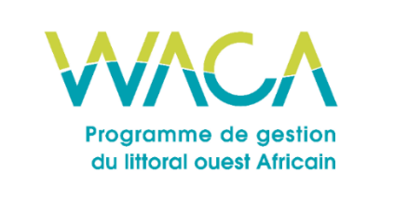
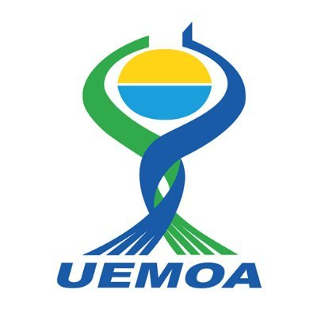
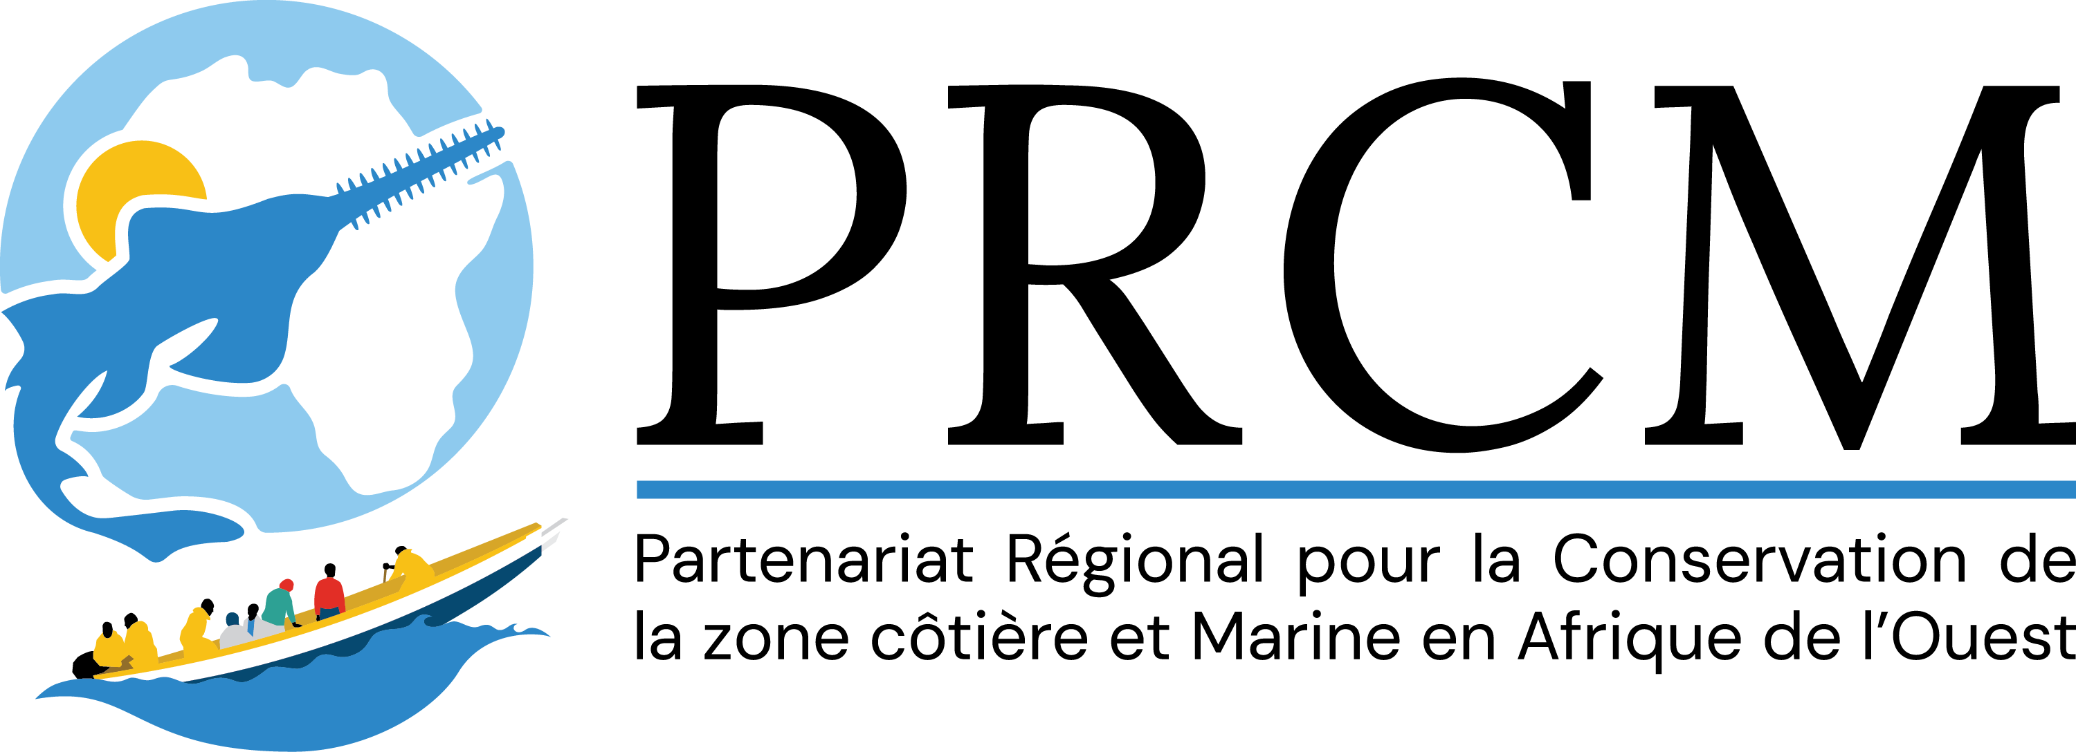

📘 FULL APP FORM (PRCM / WACA ResIP)

This form is the official framework for use by any candidate wishing to submit a complete project within the PRCM/WACA/ResIP Call for Action Research Projects (CFARPs). The italicized instructions (including this one) provide guidelines to help you write each section. They must be deleted in the final version sent to the PRCM.

🟦 I. GENERAL INFORMATION ABOUT THE PROJECT
Objective: This section aims to provide basic information about the project and the lead research institution. It helps verify that the project aligns with the priorities of the WACA ResIP program and that the supporting research institution is properly identified. Each field must be filled out accurately.
📘 Detailed instructions:
- The project title should be clear, precise, and reflect the primary goal of your intervention.
- The selected theme must align with the priorities of the call. Check only one box.
- The research institution must be specified (e.g., universities, applied research centers, specialized laboratories, scientific consortia), and the relevant legal document must be attached.
- Indicate the intervention area(s) with accurate geographical markers if possible.
- The total amount should include the PRCM contribution and all other expected contributions.
- If you are part of a consortium, specify each member's role and attach a letter of commitment from the members.

Full title of the project (to be completed by the applicant)
📌 Please fill out the table below with the requested information
Main theme of the call for research projects (tick ONLY ONE theme):  ☐ Theme 1. Analysis of coastal dynamics and risk modelling  ☐ Theme 2. Environmental Governance and Public Policy  ☐ Theme 3. Nature-based solutions and green technologies  ☐ Theme 4. Socio-anthropology and community resilience  ☐ Theme 5. Capitalization and scientific valorization | To be completed by the candidate
Candidate's full name | To be completed by the candidate
Legal status of the applicant (recognized academic or research institution) | To be completed by the candidate
Country of intervention | To be completed by the candidate
Precise geographical area (describe the locality, municipality, region concerned) | To be completed by the candidate
Estimated duration of the project (in months) | To be completed by the candidate
Total amount of the project (in euros) | To be completed by the candidate
Amount requested from the PRCM (in euros) | To be completed by the candidate
Amount and sources of co-financing (in-kind and/or cash, indicate whether confirmed or not) | To be completed by the candidate
Other members of the consortium (if there is a consortium) | To be completed by the candidate

🟦 II. IDENTITY OF THE HOLDER AND STRUCTURE OF THE CONSORTIUM (if applicable)
Objective: The purpose of this section is to show that the applicant entity or consortium has the legal, technical, and organizational capacity to carry out the proposed project.
📘 Detailed instructions:
- Briefly describe your organization, its mandate, its areas of intervention, and its presence in the project area.
- Attach your legal status, registration number, and any official documents.
- If you are submitting on behalf of a consortium, specify each member's roles, attach a signed letter of commitment, and complete the following fields for the consortium in the table below.
Name of the supporting organization | To be completed by the candidate
Brief presentation of the organisation (missions, areas of action, territorial anchoring, national/regional recognition) | To be completed by the candidate
Year of creation | To be completed by the candidate
Full contact details (address, phone, email, website) | To be completed by the candidate
Name, position and contacts of the person responsible for the project | To be completed by the candidate
In the case of a Consortium:  • Name of the Lead Partner  Partner members (Name, mission, role in the project, area of intervention):  • Attach the legal documents of the members and the letter of commitment of the group. | To be filled in

🟦 III. BACKGROUND AND RATIONALE
Objective: This section offers an understanding of the current situation of the targeted area, including ecological and socio-economic issues, as well as the existing dynamics that justify the project.
📘 Detailed instructions:
- Describe, if relevant, the ecological context of the area, including the state of ecosystems, habitat types, and existing pressures.
- Describe, if relevant, socio-economic aspects such as lifestyles, livelihoods, and populations involved.
- Mention current or past projects in the area or related to the issue, along with partnerships, synergies, and opportunities.
- Use real-world, localized data, and include a map as an appendix if needed. Write your text and justification here (up to 2 pages):
…

🟦 IV. PROBLEMS AND CHALLENGES
Objective: To clearly identify the problem(s) to be solved and the priorities for action.
📘 Detailed instructions:

Describe the main problem your project intends to solve (related to the chosen theme).

Explain the potential consequences of not taking action, such as degradation, extinction, increased vulnerability, or exclusion.

Include an initial assessment of potential risks, whether social, environmental, or operational.

Support your points with specific examples or scenarios. Write your response here (no more than one page).

🟦 V. INTERVENTION STRATEGY AND PROJECT DESCRIPTION
Objective: Demonstrate that you have a clear vision of the project's objectives, expected results, and how you will achieve those results. This section is the most important section of the form.
📘 Detailed instructions:
This section should help the selection committee understand how the project plans to offer concrete, measurable, and realistic solutions to the identified problems. It must clearly outline the objectives, expected outcomes, main activities, and intervention methods in a structured way. It is recommended that this section be limited to 3 to 4 pages.
Define a clear and affirmative overall goal in a single sentence (e.g., Improve the resilience of X communities through Y).
- List up to three specific objectives, each addressing a specific action or change, such as ecological restoration or scientific capacity building.
- Describe the measurable and achievable results expected at the end of the project for each objective (e.g., number of people trained, surface area restored, tools created or developed). Outline or list the main activities planned to accomplish each objective—be concise and provide an overview of major actions rather than a detailed operational plan.
- Explain your methodological approach, including how the project will be implemented in practice, key steps, methods, tools, or guiding principles.
- Attach a logical framework as an appendix in table format to clarify the project’s logic and demonstrate that each activity leads to an outcome contributing to an effect that supports the desired impact.
✏️ To be completed below (Maximum 3 to 4 pages):
• Overall objective: ...
•Specific objectives:
- Specific objective 1: ...
- Specific objective 2: ...
- Specific Objective 3 (optional): ...
• Expected results (Outcome) (by specific objective): This involves determining the numerical values ​​of the desired results or products after the intervention:...
• Main activities by expected results: ...
• Methodological approach: ...
• Logical framework (to be included in the appendix): the logical framework must include the reference values ​​and the target values ​​for each indicator...

🟦 VI. CONTRIBUTIONS TRANSVERSALES
Objective: Explain how your project takes into account gender, innovation, and sustainability issues.
📘 Detailed instructions:
- Gender and inclusion: How are women, youth, or marginalized groups integrated into the project? Examples include recruitment, training, and governance.
- Innovation: Does your project introduce a new solution, an original method, or an adapted technology?
- Sustainability: How will results be maintained after the CMRP grant ends? What is the exit strategy—such as integration into local policies, empowerment of actors, or data ownership?

✏️ To be completed below (2 pages maximum):
• Gender and inclusion: ...
• Proposed innovation: ...
• Sustainability of the stock (exit strategy): ...

🟦 VII. TEAM ORGANIZATION
Objective: To introduce the key members of the team, their role and skills.
📘 Detailed instructions:
- Outline the makeup of your implementation team, including partners if it is a consortium.
- For each member, specify their role in the project, core skills, and relevant experience.
- Attach the updated CVs of key members.

✏️ To be completed below (2 and 1/2 pages maximum):
- Composition of the team: ...
- Roles of each: ...
- Members' CVs attached

🟦 VIII. DETAILED TIMETABLE OF ACTIVITIES
Objective: Schedule project activities month by month and demonstrate how human resources will be mobilized.
📘 Detailed instructions
- Please provide a clear overview of the main activities along with their implementation timeline, month by month.
- Add a column indicating which team members are responsible for each activity.
- Make sure the timetable is practical compared to the advertised duration.

✏️ Example table to fill out:
Activities | Contact(s) | M1 | M2 | M3 | M4 | M5 | M6

Add more columns if your project lasts longer than 6 months. You can also present the timetable by quarter if your project's duration exceeds 6 months.

🟦 IX. DETAILED BUDGET
Objective: To present the estimated project costs transparently, item by item, clearly distinguishing between sources of funding.
📘 Detailed instructions:
- Complete a table detailing costs by activity, including the quantity, unit cost, total amount, share covered by the CMRP, and co-financing.
- Include operating expenses (coordination, logistics, monitoring, communication, etc.) in a separate section.
- Specify whether the co-financing amounts are confirmed or estimated.
✏️ Example table to fill out:
Item of expenditure | Unit | Quantity | Unit cost (€) | Total amount (€) | PRCM (€) | Co-financing (€)
Ex: 5 women's training sessions on Nature-based Solutions

🟦 X. FINANCING PLAN
Objective: To concisely present the various sources of funding for the project.
📘 Detailed instructions:
- For each donor or partner, specify the expected amount and whether this funding is confirmed or not.
- The total should align with the overall budget shown in the previous section.

✏️ Example table to fill out:
Source of funding | Amount (€) | Confirmed (Yes/No)
PRCM - WACA ResIP2 | Amount (€) | Confirmed (Yes/No)
Lessor 1 | Amount (€) | Confirmed (Yes/No)
Donor 2 | Amount (€) | Confirmed (Yes/No)
Donor 3 | Amount (€) | Confirmed (Yes/No)

🟦 XI. MONITORING AND EVALUATION SYSTEM
Objective: To show that you can track, measure, and report the project's results.
📘 Detailed instructions:
- Establish clear metrics for each expected outcome. Use SMART (Specific, Measurable, Achievable, Realistic, Time-bound) criteria.
- Specify the baseline, the target to achieve, the verification source, and the frequency of collection.
- Use a clear and organized table.

✏️ Example table to fill out:
Expected result | SMART Indicator | Initial situation | Target | Source of Audit | Follow-up frequency
E.g. The members of the 5 women's groups in zone X master the concept of SbN

🟦 XII. CHECKLIST BEFORE SUBMISSION AND SUPPORTING DOCUMENTS
Objective: Ensure the file is complete before sending.
📘 To verify:
☐ Form filled out completely
☐ Detailed budget
☐ Financing plan
☐ Detailed timeline
☐ Team Member Resumes
☐ Legal Status
☐ Map of the intervention area
☐ Logical framework
☐ Monitoring and Evaluation System

